Year 11 General Integrated Science
The Binocular Microscope

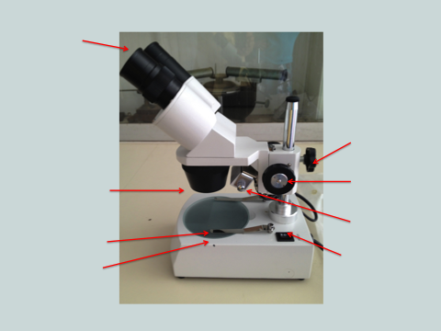

Name of part | Function
Ocular lenses

Objective lens
Stage
Stage Clips

Coarse Focus and Fine Focus knobs
Lamp
Switch

