The Ecosystem
Biogeochemical Cycling

Name: ___________________________________________ Date: __________________

Syllabus Objective
- biotic components interact with abiotic components to facilitate biogeochemical cycling

Refer to Nature of Biology: Biochemical cycles p 461- 467

The Flow of Energy
Previously, we learned that energy ____________________ through the ecosystem.
A constant supply of _____________________ is needed to maintain any ecosystem since much energy is lost from the ecosystem in the form of _______________________________
___________________________________________________________________________

Energy Flow is show with straight ___________________ in food chains and food webs. An example of a food web that may be found in a suburban ecosystem is shown in Figure 1 below.

Figure 1: _______________________________________________________________

The Cycling of Matter
In order to survive, all organisms in the ecosystem also need a constant supply of nutrients, or matter. Nutrients are the atoms that make up the matter of an organism, its cells, tissues and organs. Matter _______________________________ through ecosystems.

Nutrient cycles may be termed biogeochemical cycles. Match the definition with the part of the name.
  - The item that cycles is a chemical element; __________________________
  - For some of the cycle, the chemical is in organisms or biological material; __________________________
  - For some of the cycle, the chemical is present in non-living parts of an eco- system, for example, geological structures such as soil or rocks; __________________________

In this section we will concentrate on the interaction between the living and non-living interface.

First let’s review some chemical elements found in living things.

Chlorophyll is a molecule used by plants in the process of __________________________ .  Billions of chlorophyll molecules help give leaves their ______________________ colour.  Refer to the chlorophyll molecule in Figure 2 and list five examples of nutrient atoms that are needed by green plants. | 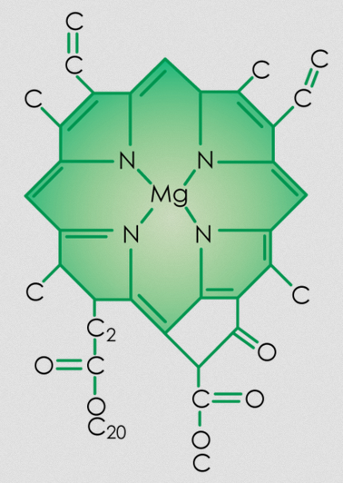  Figure 2: ____________________________________
Five nutrient atoms need by green plants;

______________________________ __________________________

______________________________ __________________________

______________________________

Haemoglobin is a molecule used by mammals in the process of transporting __________________ in the blood.  Billions of haemoglobin molecules help give blood its red colour.  Refer to the haemoglobin molecule in Figure 3 and list five examples of nutrient atoms that are needed by mammals. | 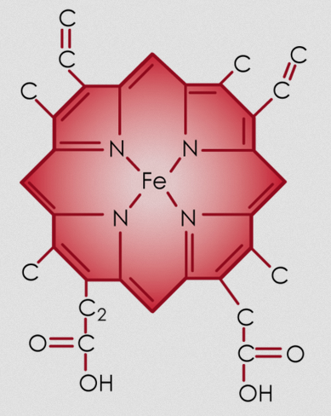  Figure 3: ____________________________________

Five nutrient atoms need by mammals;

______________________________ __________________________

______________________________ __________________________

______________________________

Refer to class PowerPoint and class discussion. (Refer to Nature of Biology if absent)

Cycles of Matter
Nutrients, or Matter is cycled through the ecosystem. These cycles are called
____________________________________________________

The four elements we will study are

__________________________ __________________________

__________________________ __________________________

These elements are passed, or cycled between the ________________________ parts and the _____________________________ parts of the ecosystem.

Hydrogen and oxygen are cycled in the compound water. Most nutrients are dissolved in water so that they can be moved around the cells, the organism, and the ecosystem!

The Water Cycle, or Hydrological Cycle
Hydrogen and oxygen are found in the common compound dihydrogen oxide, or ______________________. The chemical formula of water is ______________ .

The water cycle performs these three functions:

__________________________, __________________________

__________________________ the earth’s water.

Water Transformations
The physical changes that occur are;

- _______________________, when liquid water becomes water vapour.

- _______________________ or ________________________ when water vapour becomes liquid water.

- _______________________ or ________________________ when liquid water becomes solid water.

- _______________________, when solid water becomes liquid water.

- _______________________, is when liquid water becomes water vapour from plants.

Summarise this information in a water cycle in Figure 4 below. Ensure that you label the arrows with the name of the water transformations and show transpiration from plants.

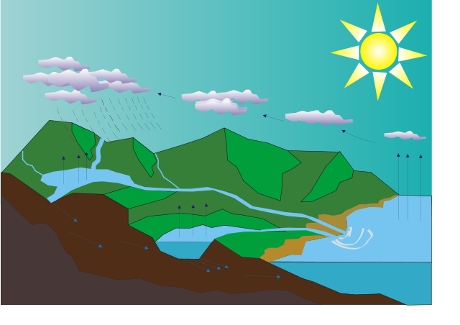

Figure 4: _______________________________________________________________

Other terminology on the water cycle.
Infiltration: __________________________________________________________________
Percolation: _________________________________________________________________
Aquifers: ___________________________________________________________________

Describe how producers cycle water.
______________________________________________________________________________________________________________________________________________________
___________________________________________________________________________

Describe how consumers and decomposers cycle water.
______________________________________________________________________________________________________________________________________________________
___________________________________________________________________________

The Carbon cycle
Carbon is an important element in living organisms because the bonds holding the carbon atoms together store ___________________ .

Processes in the carbon cycles
Photosynthesis _____________________________________________________________
Respiration ________________________________________________________________
Decomposition ______________________________________________________________
Combustion ________________________________________________________________

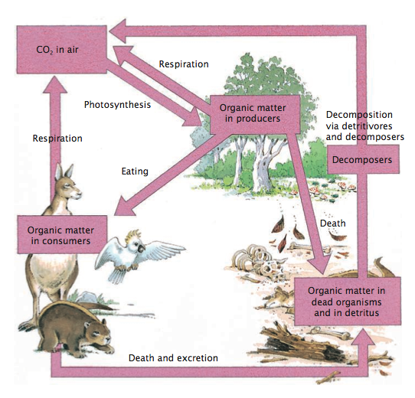
Figure 5: _______________________________________________________________

The organisms that bring carbon into the biotic parts of the ecosystem are ________________
or _______________________. They convert ______________________________ to
glucose during the process of ___________________________________________ .

All organisms, including plants release the energy from glucose during the process of ______________________________ . They convert ____________________ to ______________________________________ and water.

The Nitrogen cycle

Nitrogen is an important element in living organisms because it helps build molecules called ___________________ . Protein molecules are found in ____________________________ ,
___________________________________-, _____________________________________ ,
___________________________________ , ______________________________________ .
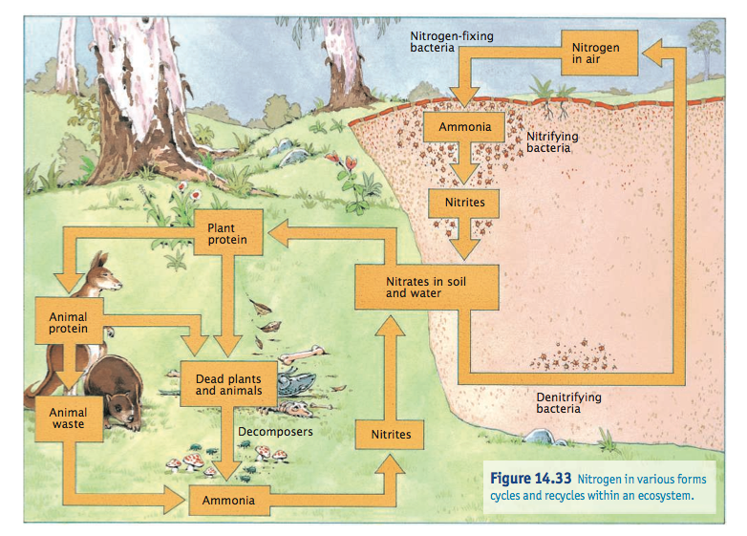
Figure 6: _______________________________________________________________

Decomposers, such as _________________, ________________, or __________________ break down the proteins in dead organisms and waste to form simple nutrients called _____________________ ( _______ ) and ______________________ ( ______ ) .

Plants, or __________________________, absorb these soluble nitrates through their ________________________ systems. Plants then build complex _________________ molecules with the nitrates.

The organisms that bring atmospheric nitrogen into the biotic parts of the ecosystem are the _________________________ and _______________________ bacteria. These bacteria convert the unreactive nitrogen gas to the simple soluble _______________________ .

Plants absorb these soluble ___________________ through their root systems. Plants then build complex _________________ molecules with the nitrates.

You and a partner will chose one of these cycles to research in more detail for Task 5.

