Biotic Components of the Ecosystem and Energy Flow

Name: ____________________________________________________________________

Part 1 Research for Task 3 due Tuesday 22 March
- producers, consumers and decomposers have a role in the transfer of energy in an ecosystem
- food chains and food webs show the feeding relationships between organisms within a community
- the amount of energy transferred between trophic levels in food chains and food webs diminishes as the trophic level increases

Ecosystems require an energy source Nature of Biology p 441
The energy source for ecosystems is _______________ energy from the ____________ .

The role of producers Nature of Biology p 443
Green plants contain the leaf pigment _____________________________ .
In the ecosystem green plants are called ________________________ .
Another name for producer is _____________________________.
- Describe the role of producers in energy transfer in the ecosystem.
__________________________________________________________________________
__________________________________________________________________________
__________________________________________________________________________

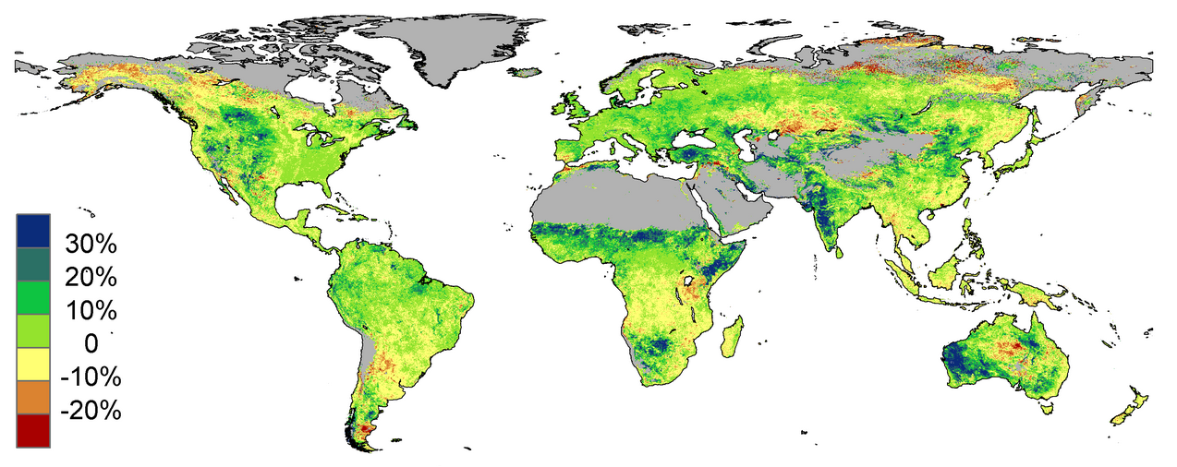
Figure 1: ________________________________________________________________
Source: http://russgeorge.net/wp-content/uploads/2014/06/Global_greening_map1.png

Producers in the Oceans are single-celled organisms called _________________________ .

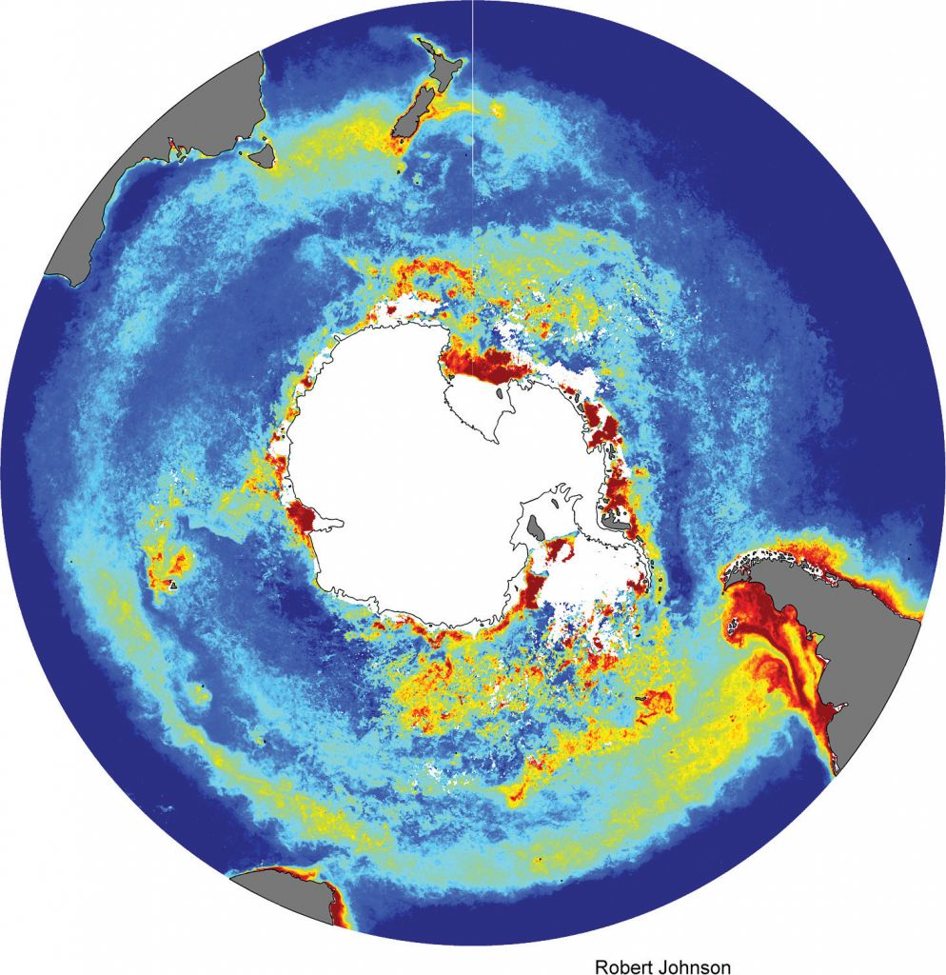 | Figure 2 shows a colour-coded image of the phytoplankton in the Southern Ocean around Antarctica.  The code:  Red and yellow indicates regions of _____________________________  and blue indicates regions of  _____________________________
Figure 2: Corrected concentrations of phytoplankton chlorophyll observed by satellites in the Southern Ocean averaged over summer from 2002 to 2012.

Source: http://www.antarctica.gov.au/magazine/2011-2015/issue-25-december-2013/science/measuring-phytoplankton-from-space

- Explain why phytoplankton are important to the marine ecosystem.

__________________________________________________________________________
__________________________________________________________________________
__________________________________________________________________________
__________________________________________________________________________
__________________________________________________________________________

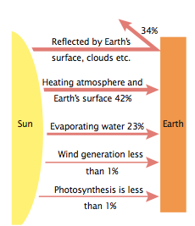  Figure 3: Solar energy coming into Earth has various fates. | Figure 3 shows the energy input to an ecosystem is in the form of the radiant energy of sunlight.  It is the ______________________ organisms, such as plants, that capture the radiant energy and transform it to chemical energy stored in organic matter, such as ___________________.  What percentage of this energy is immediately reflected out? ________________________________ .  State the percentage of light energy captured by producers from the sun. ________________________
Chemical energy is transferred from producers to consumers. Nature of Biology p 444

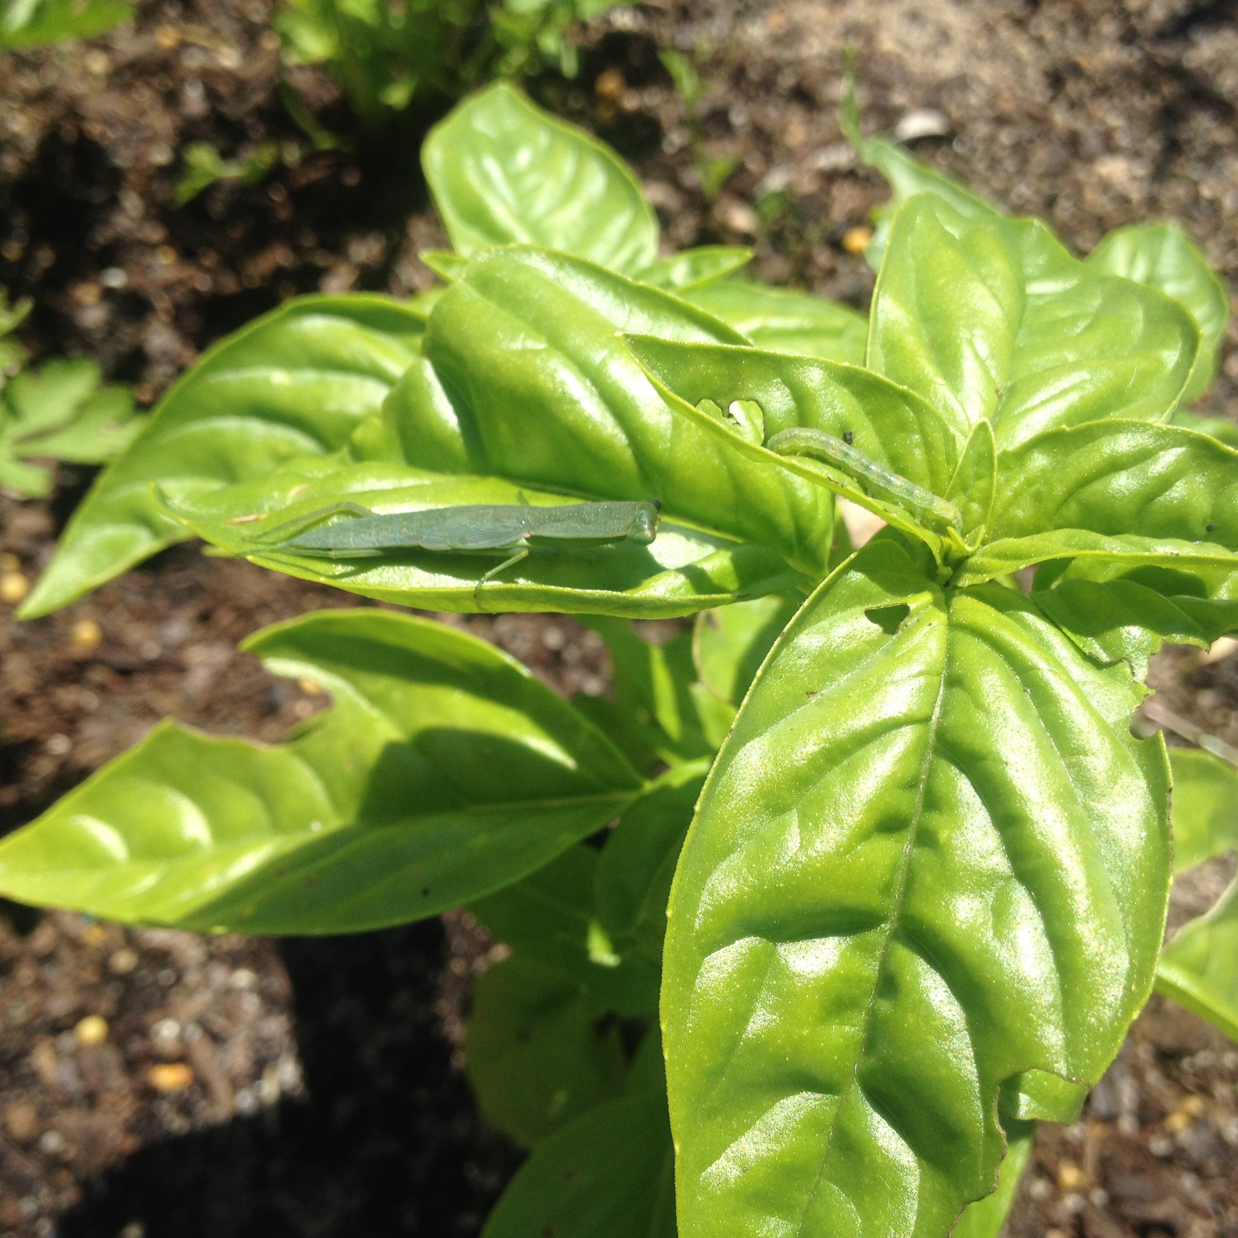  Figure 4: A food chain in action at the herb garden, John Curtin COA. | Label Figure 4;  a) Producer organism, basil, captures radiant energy of sunlight and transforms it to chemical energy of organic matter. Chemical energy in this form can be transferred from one organism to another.  (b) Herbivore organism, caterpillar, consumes the chemical energy of the producer and uses it for ____________________________________  ____________________________________ .  c) Carnivore organism, preying mantis, consumes the chemical energy of the herbivore and uses it for __________________________  ______________________________________ .

- State which is easier to transfer; radiant energy or chemical energy.
__________________________________________________________________________

- Explain why it is more difficult to put light into a box than it is to put sugar in a bag or petrol in a tank.
__________________________________________________________________________
__________________________________________________________________________

Consumers at different feeding levels Nature of Biology p 445

All the organisms in an ecosystem can be classified in terms of the major source of their nutrition;
- ________________________________ plants,
- ________________________________ animals or primary consumers.
- ________________________________carnivorous animals.

Consumers that mainly feed directly on the organic matter of producers are termed ___________________ consumers, for example, ______________________________ and other sap-sucking insects and herb-eating wallabies, or birds that eat ________________ .

Consumers that feed on primary consumers are termed_________________________ consumers, such as insects or birds that eat _____________________________.

Birds such as eagles that eat these carnivorous birds are termed ____________________ consumers or top carnivores.

Decomposers cannot be identified easily in terms of their major source of nutrition since they feed on the dead remains of plants and animals. Examples of decomposers in the herb garden ecosystem are _______________________________________________________
Producers and the various consumers in an ecosystem can also be identified in terms of their ‘feeding’ level or ______________________ level.
Summarise the information on the previous page in Table 1. Refer to Nature of Biology p 445

Table 1: _________________________________________________________________________
Trophic level | Organisms at that level | Source of chemical energy or ‘food’.

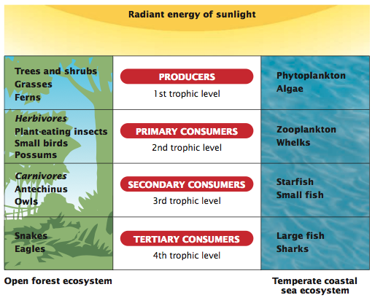
Figure 5: Comparison of producers and consumers in a terrestrial and an aquatic ecosystem.

- State the organisms that are the producers in each ecosystem.
__________________________________________________________________________
__________________________________________________________________________

- Compare and contrast the energy source for organisms at the first and third trophic levels.
__________________________________________________________________________
__________________________________________________________________________
Energy flows through an ecosystem Nature of Biology p 447

The energy input to an ecosystem is ____________________ energy of sunlight that is trans-formed by _______________________ into chemical energy stored in organic matter.

Once transformed to _________________________ energy, the energy is transferred within an ecosystem through feeding activities.
At each transfer, some energy is ‘lost’ from the ecosystem as __________________ energy.

Energy is lost at each transfer
Complete Figure 6 below.

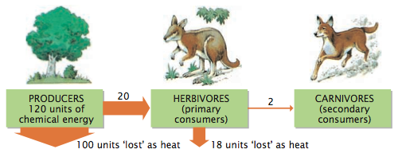

Figure 6: Energy flow in an ecosystem. The values are averages.

- Describe what happens to the amount of energy that enters a trophic (feeding) level equal to the amount that flows to the next level.
__________________________________________________________________________
__________________________________________________________________________
__________________________________________________________________________

- Explain why energy is lost at each transfer.
__________________________________________________________________________
__________________________________________________________________________
__________________________________________________________________________
__________________________________________________________________________
__________________________________________________________________________

- Draw Figure 14.14 from Nature of Biology page 447

Figure 7: The chemical energy in sugars from sunlight energy trapped by producers is used mainly by the producers themselves for staying alive. A small amount of this energy is available to consumers in the ecosystem.

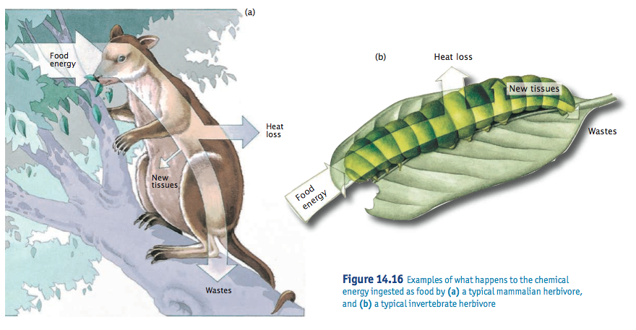
Figure 8: Examples of what happens to the chemical energy ingested as food by
(a) a typical mammalian herbivore, and (b) a typical invertebrate herbivore

- Summarise how energy is “lost” from the ecosystem.
__________________________________________________________________________
__________________________________________________________________________
__________________________________________________________________________

- State the “Ten Percent” Rule of energy transfer in ecosystems.
__________________________________________________________________________

